Lab 6: Repetition Structures
This lab accompanies Chapter 5 of Starting Out with Programming Logic & Design.

Name: _______Joy Chudasama____________________

Lab 6.1 – For Loop and Pseudocode

Critical Review

A count-controlled loop iterates a specific number of times. Although you can write this with a while or a do-while loop as performed in Lab 5, most programming languages provide a loop known as the for loop. This loop is specifically designed as a count-controlled loop.

The process of the for loop is:
- The loop keeps a count of the number of times that it iterates, and when the count reaches a specified amount, the loop stops.
- A count-controlled loop uses a variable known as a counter variable to store the number of iterations that it has performed.
- Using the counter, the following three actions take place (Initialization, Test, and Increment).

The pseudocode for a for statement looks as follows:

For counterVariable = startingValue to maxValue
Statement
Statement
Statement
Etc.
End For

Help Video: Double click the file to view video

This lab requires you to implement a count-controlled loop using a for statement.

Step 1: Examine the following code.

Constant Integer MAX_HOURS = 24
Declare Integer hours

For hours = 1 to MAX_HOURS
Display “The hour is “, hours
End For

Step 2: Explain what you think will be displayed to the screen in Step 1. (Reference: For loop, page 186):
The hour is 1
The hour is 2
The hour is 3
The hour is 4
The hour is 5
The hour is 6
The hour is 7
The hour is 8
The hour is 9
The hour is 10
The hour is 11
The hour is 12
The hour is 13
The hour is 14
The hour is 15
The hour is 16
The hour is 17
The hour is 18
The hour is 19
The hour is 20
The hour is 21
The hour is 22
The hour is 23
The hour is 24

Step 3: Write a for loop that will print 60 minutes to the screen. Complete the missing lines of code.

Constant Integer MAX_MINUTES = 60
Declare Integer minutes

For minutes = 1 to MAX_MINUTES
Display “The minute is ”, minutes
End For

Step 4: Write a for loop that will print 60 seconds to the screen. Complete the missing lines of code.

Constant Integer MAX_SECONDS =60
Declare Integer seconds

For seconds = 1 to MAX_SECONDS
Display “The second is ”, seconds
End For

Step 5: For loops can also be used to increment by more than one. Examine the following code.

Constant Integer MAX_VALUE = 10
Declare Integer counter

For counter = 0 to MAX_VALUE Step 2
Display “The number is “, counter
End For

Step 6: Explain what you think will be displayed to the screen in Step 5. (Reference: Incrementing by Values Other than 1, page 190):
The number is 0
The number is 2
The number is 4
The number is 6
The number is 8

Step 7: Write a for loop that will display the numbers starting at 20, then 40, then 60, and continuing the sequence all the way to 200.

Constant Integer MAX_VALUE = 200
Declare Integer counter

For counter = 20 to MAX_VALUE Step 20
Display “The number is “, counter
End For

Step 8: For loops can also be used when the user controls the number of iterations. Examine the following code:

Declare Integer numStudents
Declare Integer counter

Display “Enter the number of students in class”
Input numStudents

For counter = 1 to numStudents
Display “Student #”, counter
End For

Step 9: Explain what you think will be displayed to the screen in Step 8. (Reference: Letting the User Control the Number of Iterations, page 194):
Suppose the user gives the input of number 5 then output is below.

Student #1
Student #2
Student #3
Student #4

In short whatever the number is typed by user the For Loop will run until that particular number.

Step 10: For loops are also commonly used to calculate a running total. Examine the following code.

Declare Integer counter
Declare Integer total = 0
Declare Integer number

For counter = 1 to 5
Display “Enter a number: “
Input number
Set total = total + number
End For

Display “The total is: “, total

Step 11: Explain what you think will be displayed to the screen in Step 10. (Reference: Calculating a Running Total, page 201):
Enter a number:10
Enter a number:10
Enter a number:10
Enter a number:10

The total is:40

Step 12: Write the missing lines for a program that will allow the user to enter how many ages they want to enter and then find the average.

Declare Integer counter
Declare Integer totalAge = 0
Declare Real averageAge = 0
Declare Integer age
Declare Integer number

Display “How many ages do you want to enter: “
Input number
For counter = 1 to number
Display “Enter age: “
Input age
Set totalAge = age + totalAge
End For

averageAge = totalAge / number
Display “The average age is “, averageAge
Lab 6.2 –For Loop and Flowcharts

Critical Review

A flowchart for a for loop is similar to that of a while loop, where a condition controls the iterations. Here is an example of a for loop using a flowcharting tool such as Visio.
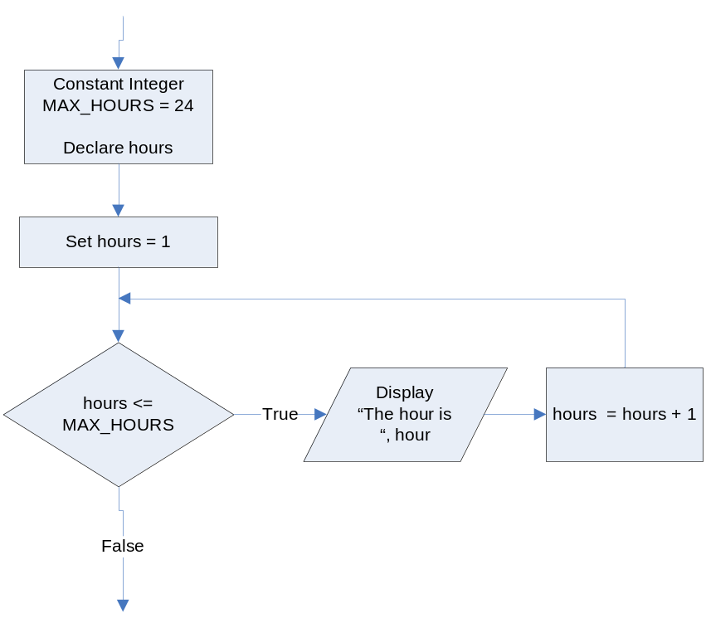

In Raptor, the for loop structure is a bit different because the programmer has less control over the loop symbol. Notice these difference in the following flowchart:

- The variables in are still declared and initialized to the same starting values.
- The condition is now hours > MAX_HOURS rather than hours <= MAX_HOURS. This is done because in Raptor, False or No statements continue the code and True or Yes statements end the code. This is the opposite as demonstrated in the textbook.
- The code within the loop is the same.

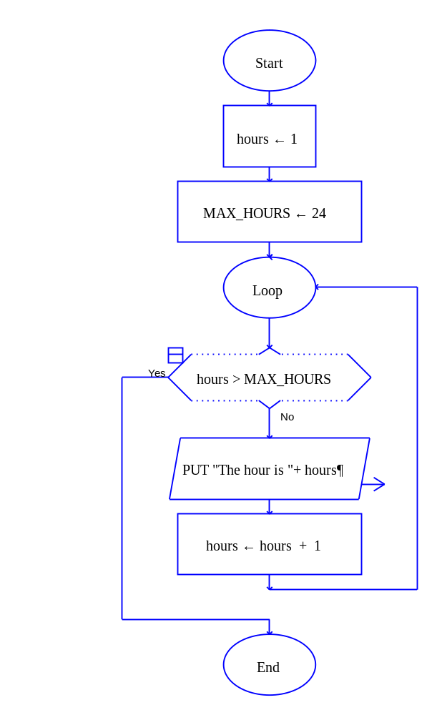

Help Video: Double click the file to view video

This lab requires you to convert various pseudocode steps in Lab 6.1 to a flowchart. Use an application such as Raptor or Visio.

The Seconds Counter
Step 1: Start Raptor and save your document as Lab 6-2Seconds. The .rap file extension will be added automatically.

Step 2: The first loop to code is the pseudocode from Step 4, Lab 6.1. This loop will print 60 seconds to the screen. The complete pseudocode is below:

Constant Integer MAX_SECONDS = 60
Declare Integer seconds

For seconds = 1 to 60
Display “The second is “, seconds
End For

Step 3: Click the Loop symbol and add it between the Start and the End symbol. Above the Loop symbol, add two assignment statements. Set a variable named seconds to 1 and a variable named MAX_SECONDS to 60.

Step 4: Double click the Diamond symbol and add the condition that will execute the loop through 60 iterations.

Step 5: Add an output statement if the loop is NO. This statement will display the seconds variable to the screen.

Step 6: Add an assignment statement next that will increment the seconds variable by 1.

Step 7: Execute your flowchart to see if your output matches the following. If not, repeat the steps to identify the error and execute again.

The second is 1
The second is 2
The second is 3
…..Continues from 4 to 57……
The second is 58
The second is 59
The second is 60
----Run finished----

Step 8: Paste your finished flowchart in the space below.

PASTE FLOWCHART HERE

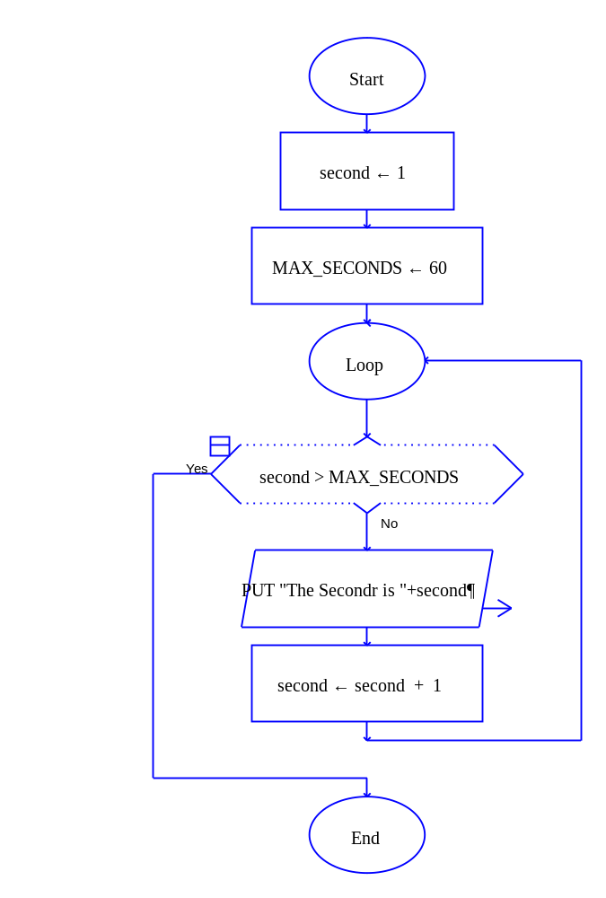
OUTPUT

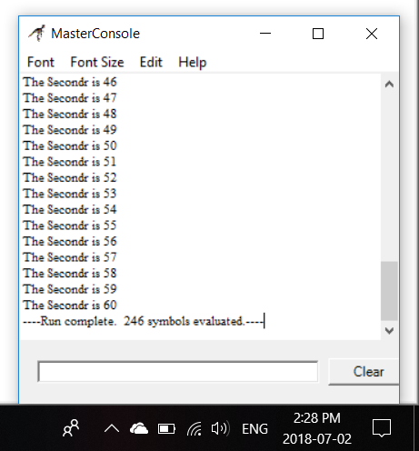

The Accumulator
Step 1: Start Raptor and save your document as Lab 6-2Accumulator. The .rap file extension will be added automatically.

Step 2: The next loop to code is the pseudocode from Step 10, Lab 6.1. This loop will take in a number and accumulate the total. The complete pseudocode is below:

Declare Integer counter
Declare Integer total = 0
Declare Integer number

For counter = 1 to 5
Display “Enter a number: “
Input number
Set total = total + number
End For

Display “The total is total: “, total

Step 3: Click the Loop symbol and add it between the Start and the End symbol. Above the Loop symbol, add three assignment statements. Set a variable named counter to 1, a variable named total to 0, and a variable named number to 0.

Step 4: Double click the Diamond symbol and add the condition that will execute the loop through 5 iterations.

Step 5: Add an input statement if the loop is NO. This statement will ask the user to enter a number.

Step 6: Add an assignment statement that will accumulate the total such as total = total + number.

Step 7: Add an assignment statement that will increment the counter variable by 1.

Step 8: Add an output statement outside of the loop if the condition is YES. This should display total.

Step 9: Execute your flowchart to see if your output matches the following. If not, repeat the steps to identify the error and execute again.

Input values are:
13
23
24
52
18

The expected output is:
The total is 130
----Run finished----

Step 10: Paste your finished flowchart in the space below.

PASTE FLOWCHART HERE
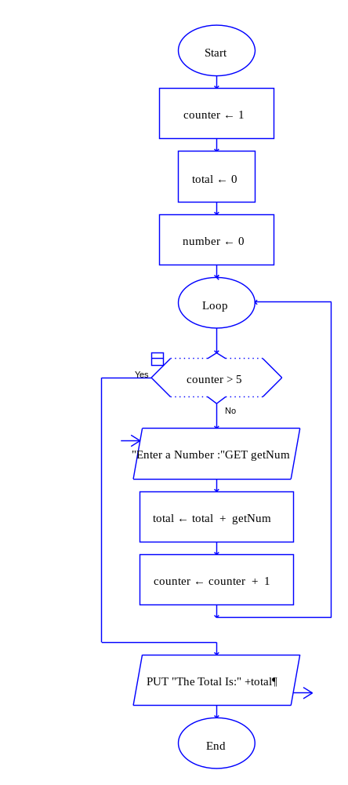
OUTPUT

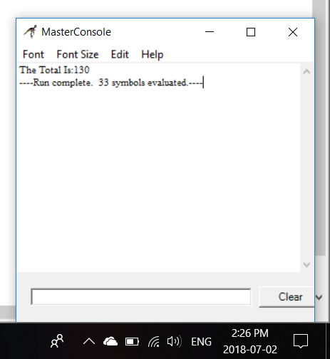
The Average Age
Step 1: Start Raptor and save your document as Lab 6-2AverageAge. The .rap file extension will be added automatically.

Step 2: The next loop to code is the pseudocode from Step 12, Lab 6.1. This loop will take in various amounts of ages and then find the average. The complete pseudocode is below:

Declare Integer counter
Declare Integer totalAge = 0
Declare Real averageAge = 0
Declare Integer age
Declare Integer number

Display “How many ages do you want to enter: “
Input number

For counter = 1 to number
Display “Enter age: “
Input age
Set totalAge = totalAge + age
End For

averageAge = totalAge / number

Display “The average age is “, averageAge

Step 3: Click the Loop symbol and add it between the Start and the End symbol. Above the Loop symbol, add five assignment statements. Set counter to 1, totalAge to 0, averageAge to 0, age to 0, and number to 0.

Step 4: Above the Loop symbol, add an Input symbol that asks the user how many ages they want to enter. Store the answer in the number variable.

Step 5: Double click the Diamond symbol and add the condition that will execute the loop as long as the number is less than the counter. This can be written as counter > number.

Step 6: Add an input statement if the loop is NO. This statement will ask the user to enter an age.

Step 7: Add an assignment statement that will accumulate the totalAge.

Step 8: Add an assignment statement that will increment the counter variable by 1.

Step 9: Add an assignment statement outside of the loop if the condition is YES. This should calculate the averageAge as averageAge = totalAge / number.

Step 10: Add an output statement outside of the loop if the condition is YES. This should display averageAge.

Step 11: Execute your flowchart to see if your output matches the following. If not, repeat the steps to identify the error and execute again.

Input values are:
4 – how many ages to enter

45
67
34
27

The expected output is:
The average age is 43.2500
----Run finished----

Step 12: Paste your finished flowchart in the space below.

PASTE FLOWCHART HERE

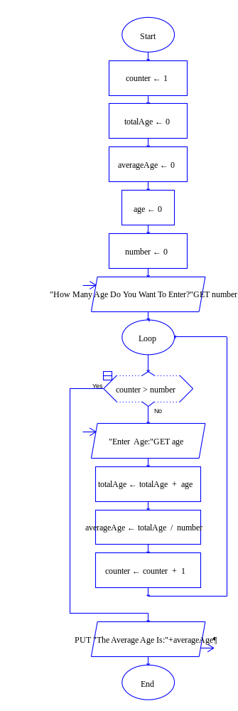

OUTPUT

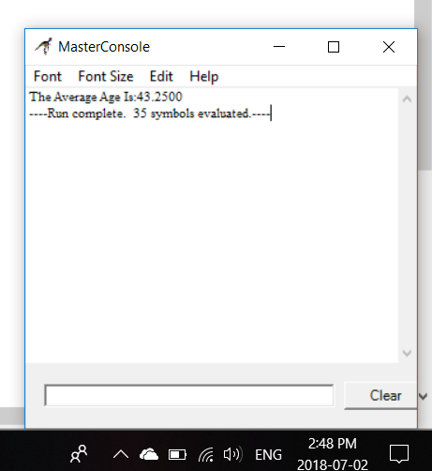
Lab 6.3 – Python Cod
Critical Review

You use the for statement to write a count-controlled loop. In Python, the for statement is designed to work with a sequence of data items. When the statement executes, it iterates once for each item in the sequence. The general format is as follows:

for variable in [value1, value2, etc.]:
statement
statement
etc.

Using the range function

When it is too cumbersome to print all the values to be displayed, Python has a range function that can be used. If you pass one argument to the range function, that argument is used as the ending limit of the list. If you pass two arguments to the range function, the first argument is used as the starting value of the list and the second argument is used as the ending limit. Here are two examples:

for num in range(5):  print num  This code will display the following:  0  1  2  3  4 | for num in range(1, 5):  print num  This code will display the following:  1  2  3  4

Letting the User Control the Number of Iterations

Sometimes the programmer needs to let the user control the number of times that a loop iterates. This is done by first letting the user enter how many times they want their loop to execute. Then, the range function is used to control the iterations. It is important to use the starting value of 0 for the loop to execute the exact number of times. The general format is as follows:

number = input('How many iterations do you want: ')

for counter in range(0, number):
Statements…
Statements…

Help Video: Double click the file to view video

The goal of this lab is to convert all flowcharts in Lab 6.2 to Python code.

Step 1: Start the IDLE Environment for Python. Prior to entering code, save your file by clicking on File and then Save. Select your location and save this file as Lab6-3.py. Be sure to include the .py extension.

Step 2: Document the first few lines of your program to include your name, the date, and a brief description of what the program does.

Step 3: Start your program with the following code for main:

#Lab 6-3 Practicing for loops

#the main function
def main():

#A Basic For loop

#The Second Counter code

#The Accumulator code

#The Average Age code

#calls main
main()

Step 4: Under the documentation for A Basic For Loop, add the following lines of code:

print 'I will display the numbers 1 through 5.'
for num in [1, 2, 3, 4, 5]:
print num

On the first iteration, 1 is placed into the variable num and num is then printed to the screen. The process is continued as follows:

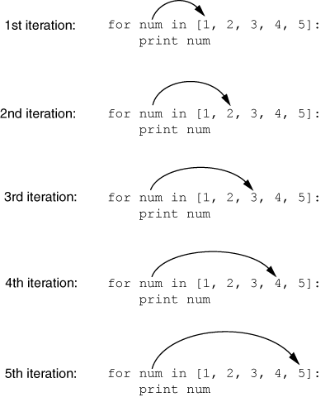

Execute your program. Notice that the output is as follows:

>>>
I will display the numbers 1 through 5.
1
2
3
4
5
>>>

Step 5: The next loop to code is the Second Counter code. This loop can be processed in the same way as Step 4; however, it would take a long time to write 1 through 60 in the for loop definition. Therefore, the range function should be used to simplify the process. Write a for loop that has a range from 1 to 61. If you stop at 60, only 59 seconds will be printed. If you only provide one argument, the starting value will be 0. (Reference the Critical Review section above for the exact syntax.)

Step 6: The next loop to code is the Accumulator code. Start by initializing a total variable to 0. This must be done in order to accumulate values.

Step 7: The next step is to write a for loop that iterates 5 times. The easiest way to do this is the following.

for counter in range(5):

Step 8: Inside the for loop, allow the user to enter a number. Then, add an accumulation statement that adds the number to total. In Python, the range function determines the number of iterations, so it is not necessary to manually increment counter.

Step 9: Outside of the for loop, use a print statement that will display the total.

Step 10: Compare your sample input and output to the following:

Enter a number: 54
Enter a number: 32
Enter a number: 231
Enter a number: 23
Enter a number: 87
The total is 427

Step 11: The final loop to code is the Average Age code. Start by initializing totalAge and averageAge to 0. (Reference the Critical Review section above on Letting the User Control the Number of Iterations).

Step 12: The next step is to ask how many ages they want to enter. Store the answer in the number variable.

Step 13: Write the definition for the for loop using the range function such as:

for counter in range(0, number):

Step 14: Inside the for loop, allow the user to enter an age.

Step 15: Inside the for loop, add the code that will accumulate age into the totalAge variable.

Step 16: Outside of the loop, calculate the averageAge as averageAge = totalAge / number.

Step 17: Outside of the loop, display the averageAge variable to the screen.

Step 18: Compare your sample input and output to the following:

How many ages do you want to enter: 6
Enter an age: 13
Enter an age: 43
Enter an age: 25
Enter an age: 34
Enter an age: 28
Enter an age: 43
The average age is 31
>>>

Step 18: Execute your program so that all loops work and paste the final code below

PASTE CODE HERE

'''
Name : Joy Chudasama
Date : 2nd July, 2018
Description : Following programs will use "range" in order to print 1 to 5 and 1 to 60 for the second program.
In Third program simply using "range(5)" program will take input 5 times then it will calculate the total.
And in the Fourth program first it will ask for a number in order to print statement until the program get
that specific number then it will calculate total and average.
'''
def main():
print("I will Display the Numbers 1 through 5.")
for num in[1, 2, 3, 4, 5]:
print(num)
print("\n><><><><><><><><><><><><><><><><><>\n")
for num1 in range(1, 61):
print(num1)
print("\n><><><><><><><><><><><><><><><><><>\n")
total = 0
for counter in range(5):
num2 = int(input("Enter The Number: "))
total = total + num2
print("The Total Is: ", total)
print("\n><><><><><><><><><><><><><><><><><>\n")
totalAge = 0
averageAge = 0
number = int(input("How many Ages do you want to enter? :"))
for counter in range(0, number):
age = int(input("Enter An Age:"))
totalAge = totalAge + age
averageAge = totalAge / number
print("The Average Age Is:", averageAge)
main()

Lab 6.4 – Programming Challenge 1 – 78

Write the Flowchart and Python code for the following programming problem based on the provided pseudocode.

Help Video for Raptor: Double click the file to view video

Help Video for Python: Double click the file to view video

Write a program that will allow a teacher to calculate the average test score for a certain number of students. The teacher can enter the number of students who took the test, and then the score for each student. Your program will then calculate the average score and print out the results. Your program must use the appropriate loop, modules, and run multiple times for different sets of test scores.

Your sample output might look as follows:

How many students took the test: 9
Enter their score: 98
Enter their score: 78
Enter their score: 99
Enter their score: 92
Enter their score: 87
Enter their score: 100
Enter their score: 88
Enter their score: 81
Enter their score: 79
The average test score is 89
Do you want to end program? (Enter no to process a new set of scores): yes
The Pseudocode

Module main()
//Declare local variables
Call declareVariables (endProgram, totalScores, averageScores, score, number, counter)

//Loop to run program again
While endProgram == “no”
//reset variables
Call declareVariables (endProgram, totalScores, averageScores, score, number, counter)

//calls functions
Call getNumber(number)
Call getScores(totalScores, number, score, counter)
Call getAverage(totalScores, number, averageScores)
Call printAverage(averageScores)
Display “Do you want to end the program? (Enter no to process a new set of test scores )”
Input endProgram
End While
End Module

Module declareVariables(Real Ref endProgram, Real Ref totalScores, Real Ref averageScores, Real Ref score, Integer Ref number, Integer Ref counter)
Declare String endProgram = “no”
Declare Real totalScores = 0.0
Declare Real averageScores = 0.0
Declare Real score = 0
Declare Integer number = 0
Declare Integer counter = 1
End Module

Module getNumber(Integer Ref number)
Display “How many students took the test: ”
Input number
End Module

Module getScores(Real Ref totalScores, Integer number, Real score, Integer counter)
For counter = 1 to number
Display “Enter their score:”
Input score
Set totalScores = totalScores + score
End For
End Module

Module getAverage(Real totalScores, Integer number, Real Ref averageScores)
Set averageScores = totalScores / number
End Module

Module printAverage(Real averageScores)
Display “The average scores is “, averageScores
End Module

The Flowchart

PASTE FLOWCHART HERE

- main()

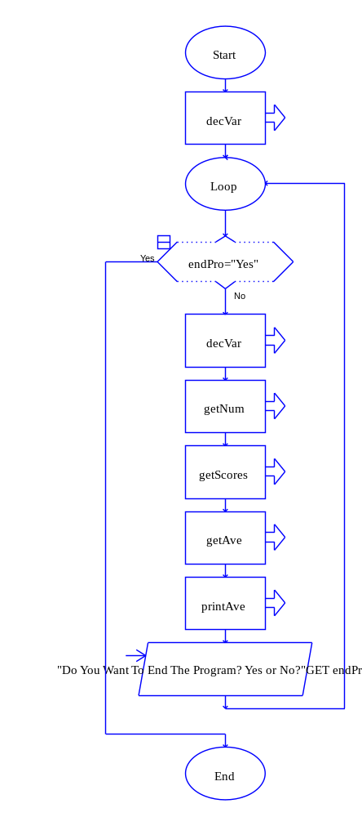
2. decVar ()

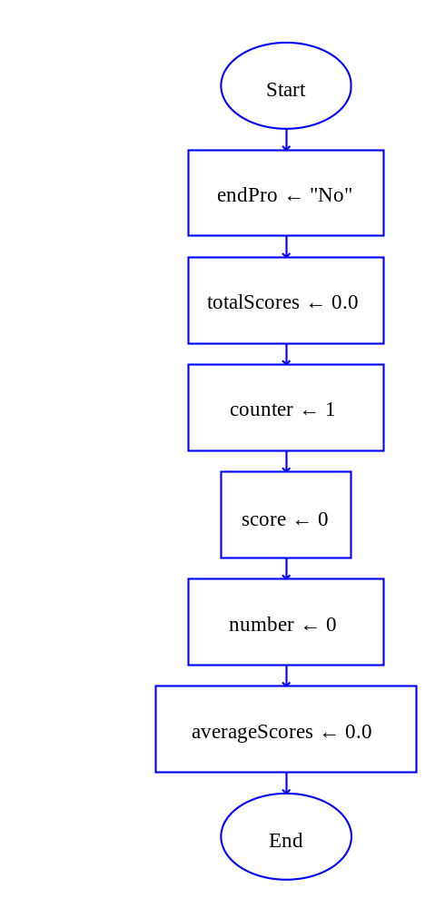

3. getNum ()

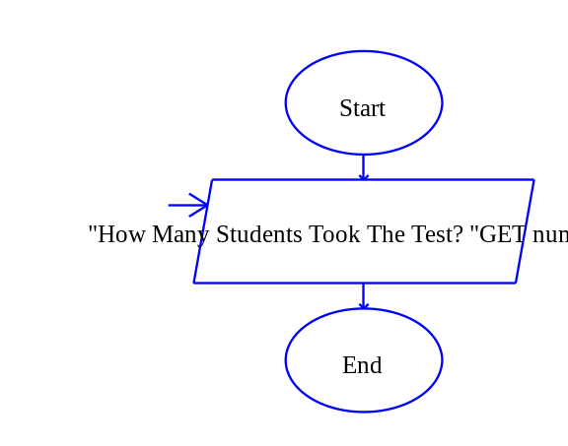
4. getScores ()

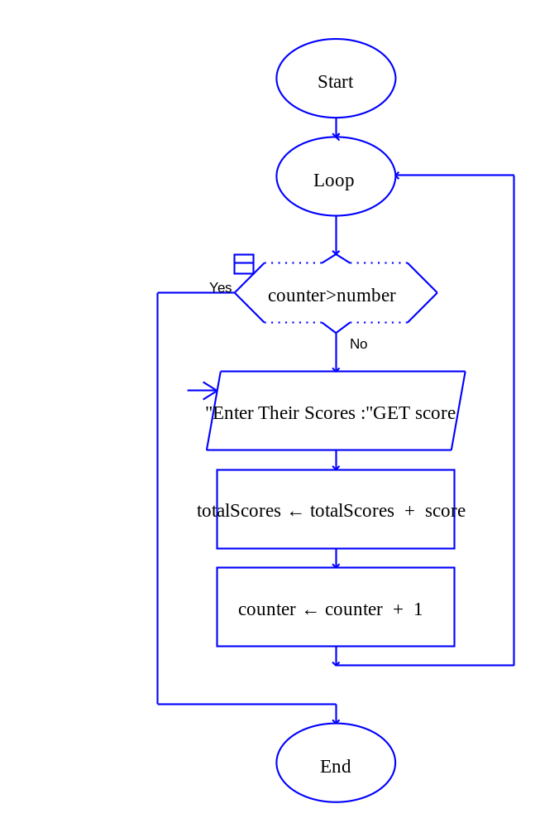

5. getAve ()

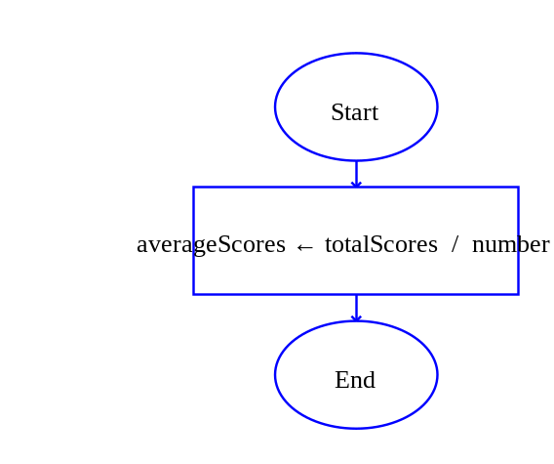
6. printAve ()

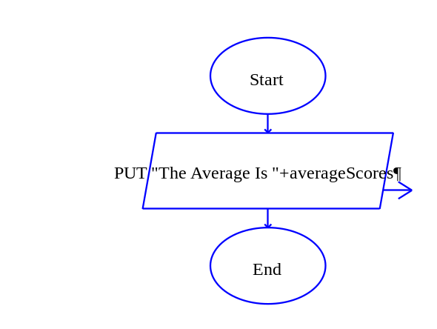

7. OUTPUT

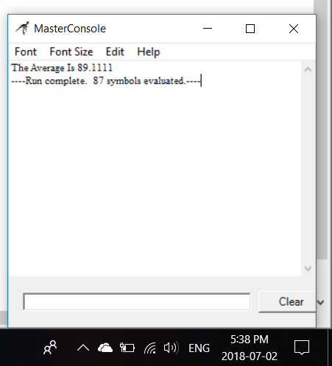
The Python Code

PASTE CODE HERE

def main():
endPro, totalScores, averageScores, score, number, counter = decVar()
while endPro == "No":
endPro, totalScores, averageScores, score, number, counter = decVar()
number = getNum()
totalScores = getscore(totalScores,number)
averageScores=getAverage(totalScores,number)
printAve(averageScores)
endPro=input("\nDo You Want To End The Program? Yes or No? :")
def decVar():
endPro="No"
totalScores=0.0
averageScores=0.0
score=0
number=0
counter=1
return endPro, totalScores,averageScores, score, number, counter
def getNum():
number=int(input("\n\t\t\t\tHow Many Students Took The Test? :"))
return number
def getscore(totalScores,number):
for counter in range(number):
score=int(input("\nEnter Their Scores : "))
totalScores=totalScores + score
return totalScores
def getAverage(totalScores,number):
averageScores= totalScores / number
return averageScores
def printAve(averageScores):
print("\n\t\t\t\tThe Average Score Is %d"%averageScores)
main()

